Name: __SOLUTIONS________
Full Test (Calc Free + Calc Assumed)

Total Time: 27 minutes

Total Marks: 21 marks

Student Result ________/ 21

MATHEMATICS METHODS Unit 3
TEST 1 -2023: Further differentiation, integration and applications.
Part B

Calculator Free Section
Time: 11 minutes
Total Marks: ______ / 8 marks

Resources allowed: SCSA Formula Sheet

Instructions to candidates
Show all your working clearly. Your working should be in sufficient detail to allow your answers to be checked readily and for marks to be awarded for reasoning. Incorrect answers given without supporting reasoning cannot be allocated any marks. For any question or part question worth more than two marks, valid working or justification is required to receive full marks. If you repeat any question, ensure that you cancel the answer you do not wish to have marked.

Question 1 | [1, 2, 2 = 5 marks]

Consider the function $f\left(x\right)$ shown below.
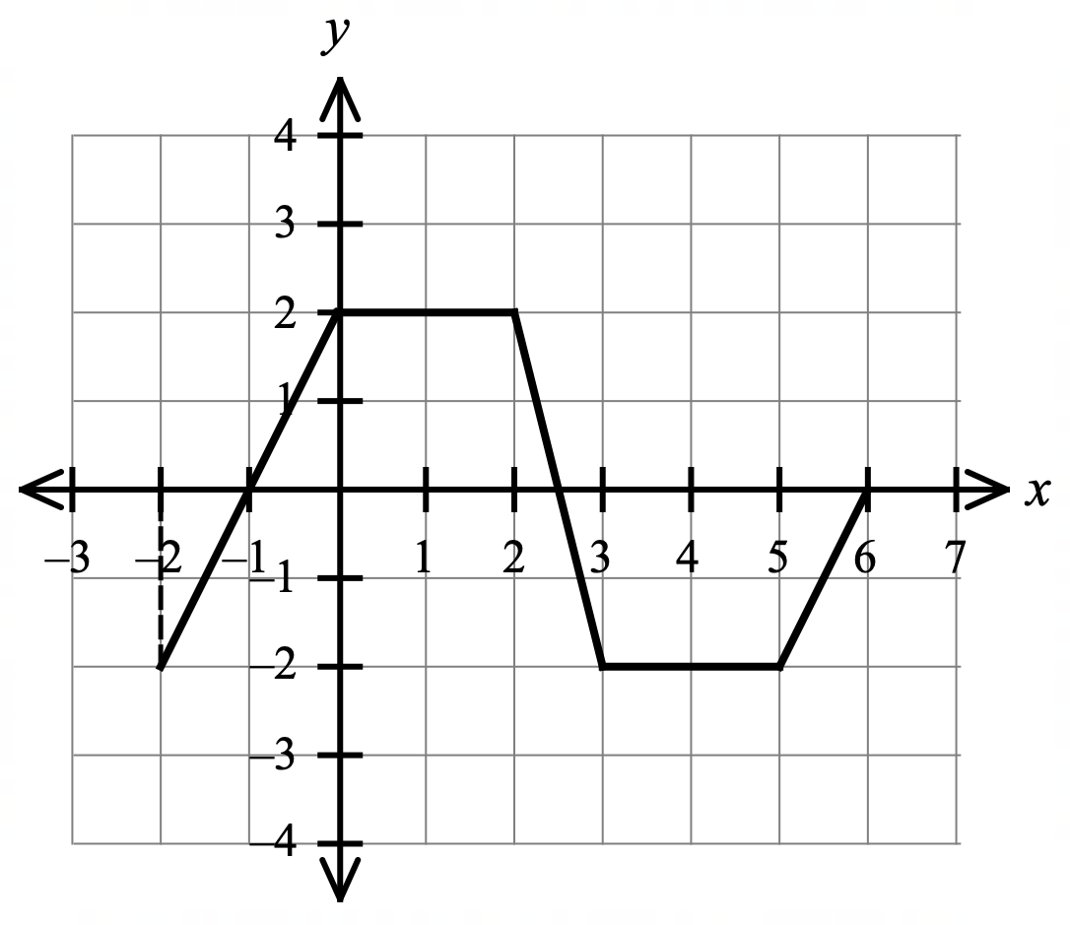

Evaluate the following integrals.
$$\int_{-2}^{2}{f\left(x\right)} dx$$

a)

$=signed area under the curve from x=-2 to x=2$

$=\int_{-2}^{0}{f\left(x\right)} dx+\int_{0}^{2}{f\left(x\right)} dx$

$=0+4=4$ determines correct value (signed area)
$$\int_{-1}^{6}{f\left(x\right)+2} dx$$

b)

$=\int_{-1}^{6}{f\left(x\right)} dx+\int_{-1}^{6}{2} dx$ applies integral property

$=0+{\left[2x\right]}_{-1}^{6} dx$

$=12-\left(-2\right)=14$ determines correct value (signed area)
$$\int_{6}^{2}{-2f\left(x\right)} dx$$

c)

$=-\int_{2}^{6}{-2f(x)} dx$

$=-(-2)\int_{2}^{6}{f(x)} dx$ applies integral properties

$=2\left(-5\right)=-10$ determines correct value (signed area)

Question 2 | [1, 2 = 3 marks]

Determine
$$\frac{d}{dx}\int_{0}^{x}{\sqrt{t^{2}-3}}dt$$
a)

$=\sqrt{x^{2}-3}$ uses the Fundamental Theorem of Calculus

$$\frac{d}{dx}\int_{x}^{2}{4t^{3}-3t} dt$$

b)

$=-\frac{d}{dx}\int_{2}^{x}{4t^{3}-3t} dt$ applies definite integral property $\int_{b}^{a}{f\left(x\right)dx}=-\int_{a}^{b}{f\left(x\right)dx}$

$=-\left(4x^{3}-3x\right)$ indicates use of the Fundamental Theorem of Calculus

$=-4x^{3}+3x$

Name: __SOLUTIONS________

MATHEMATICS METHODS Unit 3
TEST 1 -2023: Further differentiation, integration and applications.
Part B

Calculator Assumed Section
Time: 16 minutes
Total Marks: ______ / 13 marks

Resources allowed:
SCSA Formula Sheet
Up to three Calculators and
One A4 sheet, both sides of notes

Instructions to candidates
Show all your working clearly. Your working should be in sufficient detail to allow your answers to be checked readily and for marks to be awarded for reasoning. Incorrect answers given without supporting reasoning cannot be allocated any marks. For any question or part question worth more than two marks, valid working or justification is required to receive full marks. If you repeat any question, ensure that you cancel the answer you do not wish to have marked.

Question 3 | [1, 2, 3, 1 = 7 marks]

The rate of flow of water from a reservoir is given by $\frac{dV}{dt}=300\sqrt{2t+1}$ for $0≤t≤24$, where $V$ is measured in litres and $t$ is the number of minutes since the sluice gates have be further opened. The sluice gates are initially slightly open and are fully open after 24 minutes.

a) Find the rate of flow (in litres per minute) when $t=0$ and $t=4$.

${\left.\frac{dV}{dt}\right|}_{t=0}=300\sqrt{1}=300$ L/minute

${\left.\frac{dV}{dt}\right|}_{t=4}=300\sqrt{9}=900$ L/minute
correct rate of flow for both times

b) Sketch the graph of $\frac{dV}{dt}$ against $t$ for $0≤t≤24$.
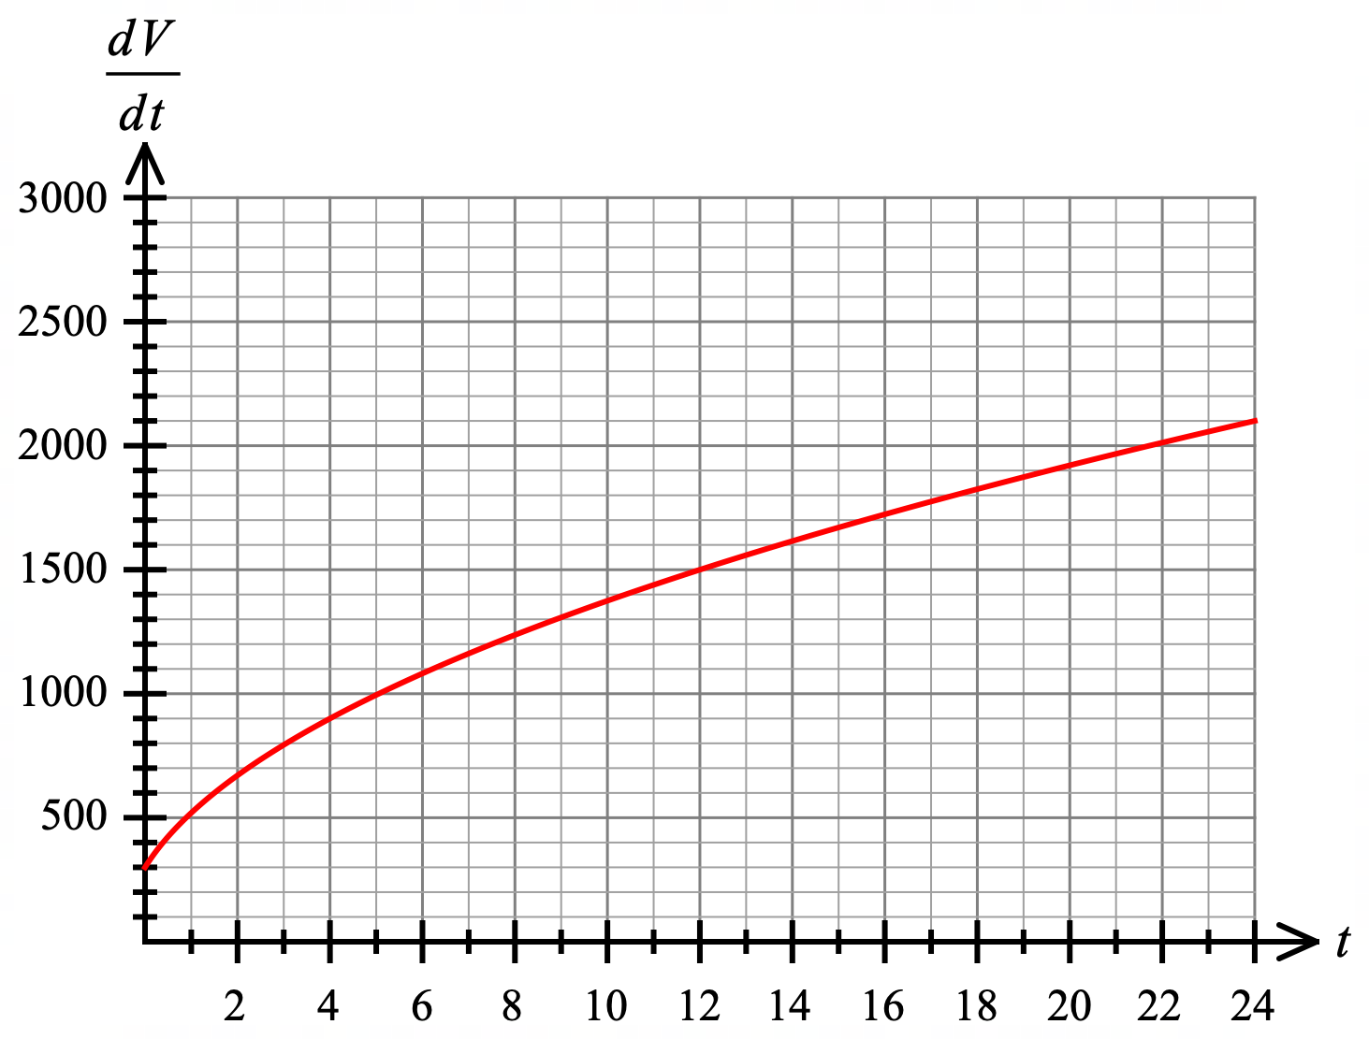

graph bounds are $(0, 300)$ and $(24, 2100)$
graph passes through $(4, 900)$ and has approximately the correct shape.

c) Determine the area under the curve of $\frac{dV}{dt}$ between $t=0$ and $t=24$.

$area=\int_{0}^{24}{300\sqrt{2t+1}} dt$ shows required integral

$=150\int_{0}^{24}{2{\left(2t+1\right)}^{\frac{1}{2}}} dt$

$=150{\left[\frac{{\left(2t+1\right)}^{\frac{3}{2}}}{\frac{3}{2}}\right]}_{0}^{24}$ correctly integrates: equiv. to ${\left[100{\left(2t+1\right)}^{\frac{3}{2}}\right]}_{0}^{24}$

$=100{\left[{\left(\sqrt{2t+1}\right)}^{3}\right]}_{0}^{24}$

$=100\left(7^{3}-1^{3}\right)$

$=34 200$ correct value for area

d) What does this area represent?

The area (answer to part c)) represents the total volume of water (in L) being released from the reservoir during in the 24 minutes in question.

indicates total volume of water

Question 4 | [2, 4 = 6 marks]

A small body with an initial displacement and velocity of 8 m and $\frac{5}{3}$ $m/s$ respectively, travels in a straight line with acceleration at time $t$ of $a=\frac{1}{2}t-2$ $m/s^{2}$ , $t≥0$.

a) Determine an expression for the velocity.

$v\left(t\right)=\int{\left(\frac{1}{2}t-2\right)dt}$

$=\frac{t^{2}}{4}-2t+c$ integrates acceleration

$v\left(0\right)=\frac{5}{3}=\frac{0^{2}}{4}-2\left(0\right)+c$ $⇒c=\frac{5}{3}$

$v\left(t\right)=\frac{t^{2}}{4}-2t+\frac{5}{3}$ determines value for $+c$

b) Calculate the displacement of the body when it has a velocity of $\frac{41}{3} m/s$.

$x\left(t\right)=\int{\left(\frac{t^{2}}{4}-2t+\frac{5}{3}\right)dt}$

$=\frac{t^{3}}{12}-t^{2}+\frac{5t}{3}+c$ integrates velocity

$x\left(0\right)=8=\frac{0^{3}}{12}-0^{2}+\frac{5(0)}{3}+c$ $⇒c=8$

$x(t) =\frac{t^{3}}{12}-t^{2}+\frac{5t}{3}+8$ determines value for $+c$

Solve for when $v=\frac{41}{3} m/s$ using CAS

solve$\left(v\left(t\right)=\frac{t^{2}}{4}-2t+\frac{5}{3},t\right)$ $⇒t=12$ solves for time when velocity $=\frac{41}{3}$

$x\left(12\right)=\frac{{12}^{3}}{12}-{12}^{2}+\frac{5(12)}{3}+8$

$=28$ m (right of the origin) determines required displacement

End of Test

